**MINIPROJECT**

Sub Topic : **Ticket Cancellation**.

Assumptions:

* The train, passenger and previous transaction data are stored in three tables YTDB, YPDB, YFDB.
* Reservation and Payment are done and the corresponding data are updated.
* The status column of the Final Database Table (YFDB) is updated as Confirmed and are updated as “cancelled”, once the user cancels the booking.
* For admin as the Passenger and the Final tables are updated by the registration and payment section, these data are accessible only in display mode and Only train database can be edited.

The Passenger Id field is a mandatory field but can be bypassed by EXIT and ADMIN commands.

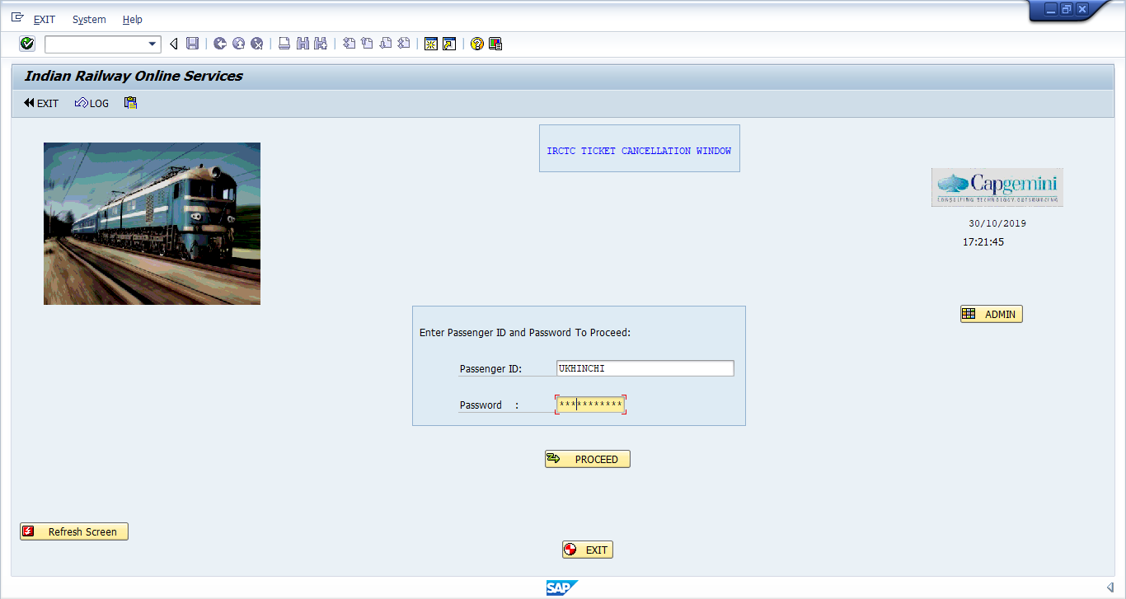

1. Second Screen Shows all the booking done by the Particular User Confirmed as well as the cancelled ones.

User can Select a confirmed booking and proceed to cancel it . A message is shown if a cancelled booking is selected.

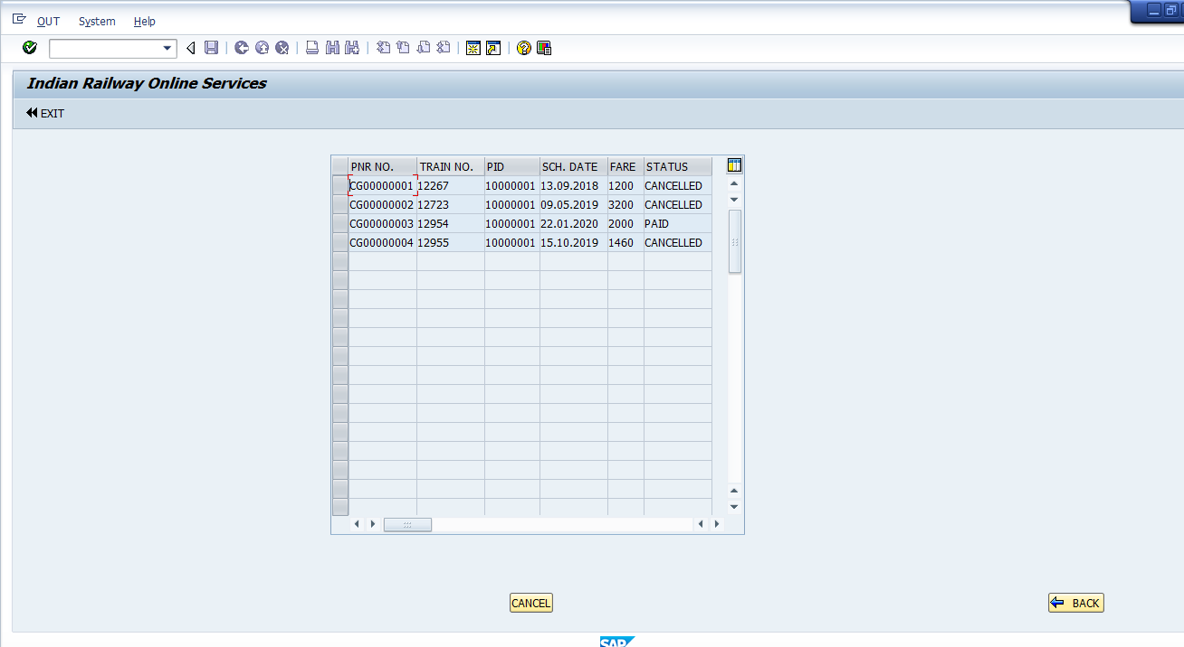

1. Cancellation confirmation Screen shows details of the booking selected to be cancelled . If another booking needs to be selected user can Select Another Booking and cancel it.

In this window if the user is sure to cancel the displayed booking he can press cancel to print the receipt.

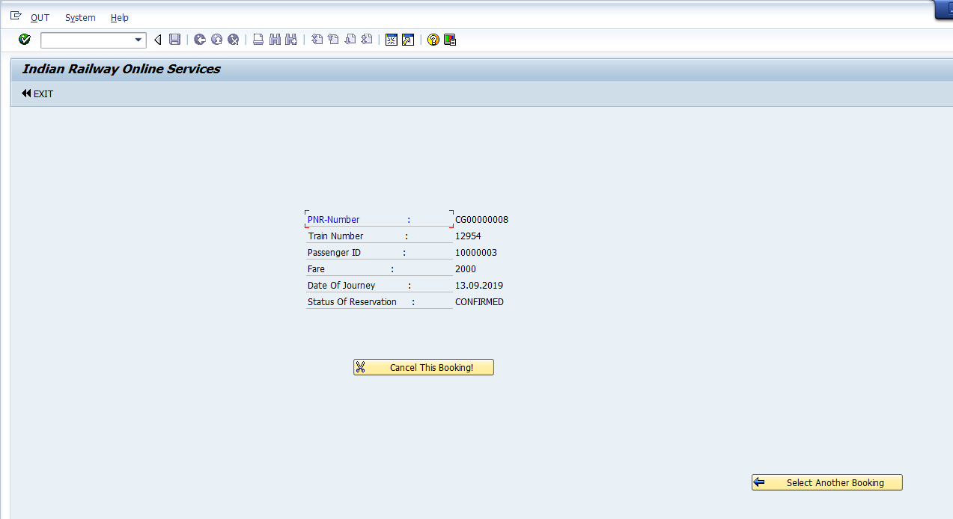

1. Print Invoice Button Is now made visible and can be used to print the adobe form.

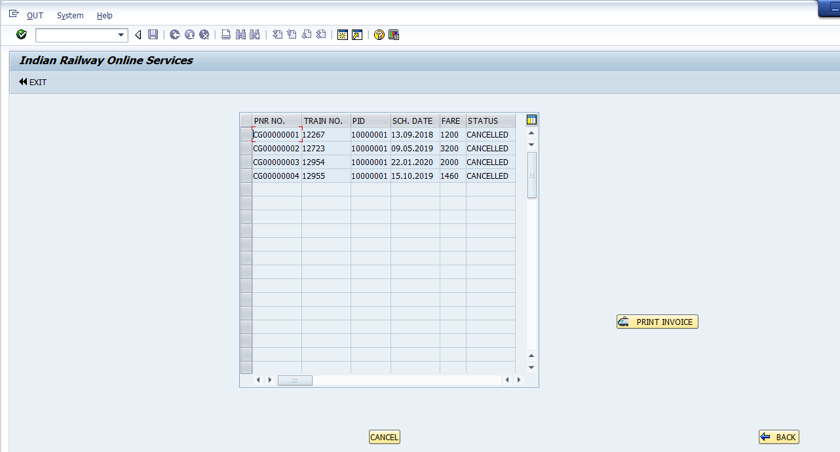

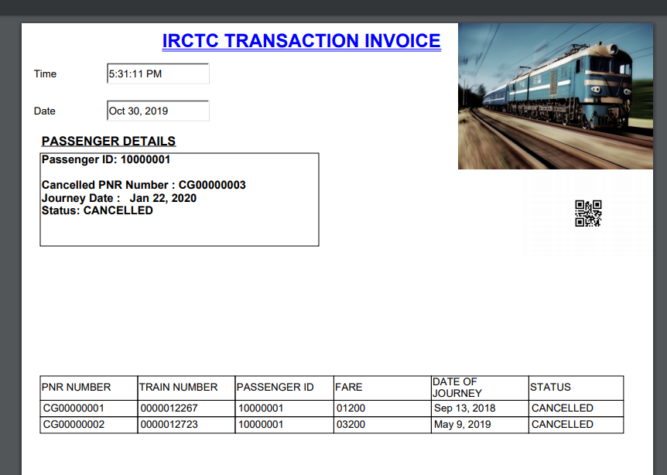

1. Now once user goes Back. Admin can login from the same page by clicking on the Admin pushbutton.

Once the admin push button is pressed the required fields appear on the screen.

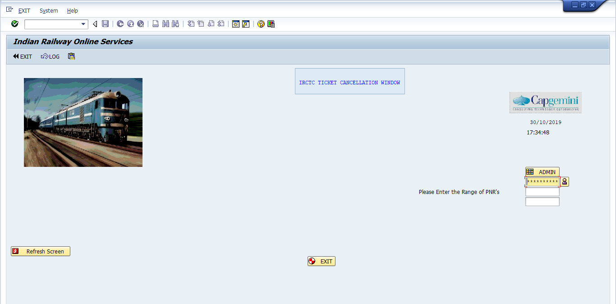

1. Once Admin Logs in he is directed to the alv of final database table. In top right corner he can navigate to other table and filter the output by giving limits in the input fields that appear correspondingly as the table selected in drop down. Press on go to see the details table.

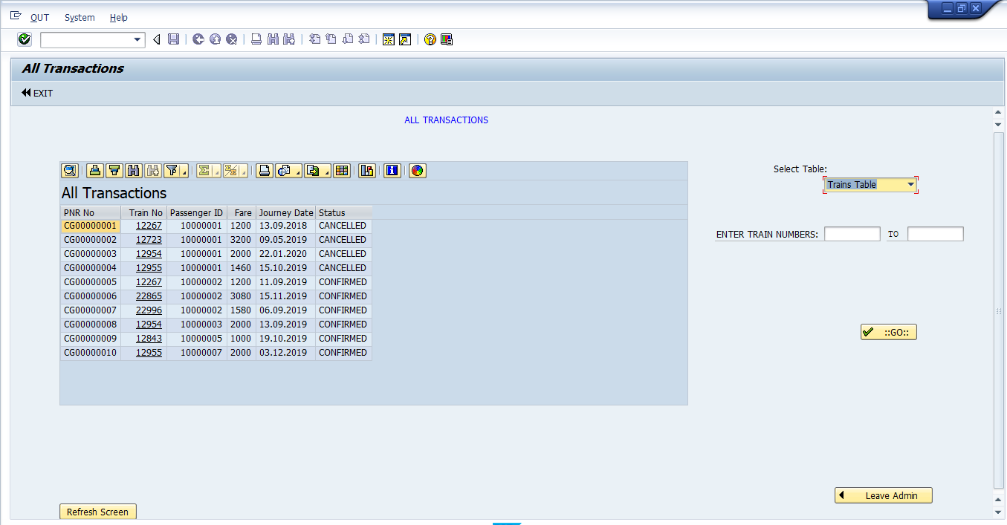

1. In train details there is an option EDIT for editing the data base ie. perform DML operations.

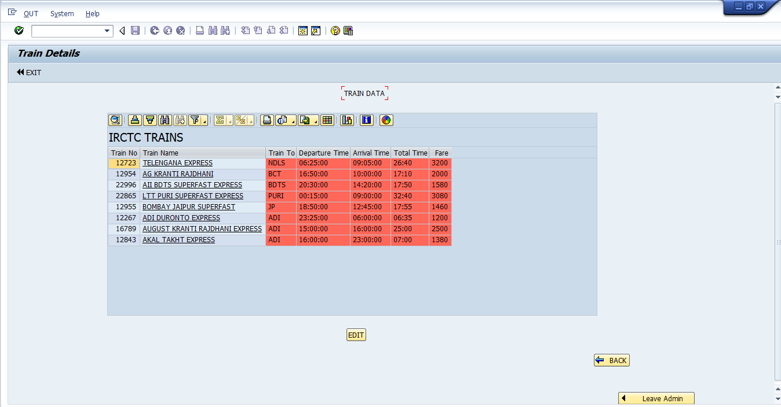

1. EDIT takes admin to the editing screen where the DML operations can be performed.

